
Graduation 2025 Accommodation Booking Form CARMARTHEN CAMPUS

This form must be returned no later than Friday 27th June 2025

Contact Details
First Name: |  | Surname:
Address:
Postcode: |  | Phone:
Email:
Student No:

• | En-suite single ensuite room | @ £45.00 per person per night
I wish to apply for accommodation, (please complete boxes as required):

 | Sunday 6th July 2025 | Monday 7th July 2025 | Tuesday 8th July 2025
Number of Rooms Required
Name of Occupants
Payment of £45 per room paid – Please confirm amount paid and payment reference number.

Please Note:

- Keys are to be collected from and returned to Main Reception in Dewi Building
- For fire safety reasons, no more than 1 occupant in a single room can be accommodated.

Payment:

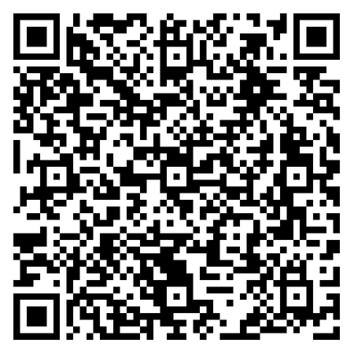
Payment to be made prior to arrival through
the online payment system by scanning
the QR code opposite. Once booking has been made,
please bring a copy of your payment receipt ‐ this
will be required in order to release the room
key upon your arrival.

Please return this form to
accommodation@uwtsd.ac.uk

Graddio 2025
Ffurflen Archeb Llety
CAMPWS CAERFYRDDIN

Rhaid dychwelyd y ffurflen hon erbyn dydd Gwener 27ain Mehefin 2025 fan bellaf

Contact Details
Enw Cyntaf: |  | Cyfenw
Cyfeiriad
Côd Post |  | Rhif ffôn
E-bost
Rhif Myfyriwr

• | Ystafell sengl en-suite | @ £45.00 y person y noson
Hoffwn wneud cais am lety, (cwblhewch y blychau yn ôl yr angen):

 | Dydd Sul 6ed  Gorffennaf 2025 | Dydd Llun 7fed Gorffennaf 2025 | Dydd Mawrth 8fed Gorffennaf 2025
Nifer os ystafelloedd sydd angen
Sawl person fydd yn aros?
Taliad o £45 am bob ystafell a dalwyd – Cadarnhewch y swm a dalwyd a rhif cyfeirnod y taliad

Nodir:

- Dylid casglu a dychwelyd allweddi i’r brif dderbynfa yn adeilad Dewi
- Am resymau diogelwch tân, ni ellir darparu ar gyfer mwy nag un person ymhob ystafell wely

Taliad:
Dylid gwneud taliad am eich hystafell cyn cyrraedd
ar y system dalu ar-lein drwy sganio’r côd QR yma.
Dewch â copi o’r dderbynneb gyda chi fel cadarnhad
er mwyn casglu allwedd eich ystafell.

Dychwelwch y ffurflen hon i
accommodation@uwtsd.ac.uk

