Biodiversity and Resilience of Ecosystems Duty
Report 2023–2025

This document is available in Welsh and English

Introduction and Context

About the Public Authority and Its Functions
The University of Wales Trinity Saint David (UWTSD) is a multi-campus higher education institution operating across Wales and England, with delivery in Wales in Lampeter, Carmarthen, Swansea and Cardiff. The University’s core functions include education, research, estates management, procurement, and community engagement. Through these functions, UWTSD has both direct and indirect influence on biodiversity and the resilience of ecosystems.
UWTSD is subject to the Well-being of Future Generations (Wales) Act 2015 and actively contributes to Public Service Boards (PSBs). The University has regard to Natural Resources Wales Area Statements and the principles of Sustainable Management of Natural Resources (SMNR) when planning and delivering its activities.
The University of Wales Trinity Saint David confirms that, in exercising its functions, it has had regard to the biodiversity and resilience of ecosystems duty under Section 6 of the Environment (Wales) Act 2016. This report demonstrates how biodiversity considerations have been embedded into strategic planning, estates management, procurement, and community engagement in alignment with Welsh Government guidance and Natural Resources Wales Area Statements.

Strategic Context and Contribution to Well-being Goals
Enhancing biodiversity contributes directly to the University’s strategic objectives and to multiple Well-being of Future Generations goals, in particular:
- A Resilient Wales through habitat creation, species protection, and resilient ecological networks
- A Healthier Wales by improving access to high-quality green spaces that support mental and physical wellbeing
- A Globally Responsible Wales through alignment with national and international biodiversity commitments
- A Prosperous Wales by reducing long-term maintenance costs and increasing climate resilience.
- Cohesive Communities through volunteering, education, and community partnerships.
The University applies the five ways of working (long-term, prevention, integration, collaboration and involvement) through long-term habitat management plans, preventative approaches to habitat degradation, and strong partnership working.

Policies, Objectives and Monitoring
Biodiversity delivery is guided by the UWTSD Biodiversity Action Plan (BAP) and the Biodiversity and Eco-Systems Forward Plan 2025. Biodiversity considerations are embedded into:
- Corporate and estates planning
- Procurement processes
- Development and capital project design
- The Environmental Management System
Monitoring includes annual BAP reviews, ecological surveys, biodiversity metrics, and regular reporting to senior leadership.

Governance Arrangements
Governance for the Section 6 duty is provided through Sustainability Steering Group, chaired by the Chief Operating Officer and supported by the Sustainability Manager. The SSG meets termly and reports to the Resources and Performance Committee, ensuring accountability and strategic oversight at governance level.

Highlights, Key Outcomes and Issues

Key Actions and Outcomes
- Completion of baseline Phase 1 ecology surveys across campuses
- Expansion of wildflower meadows and reduced-mowing regimes
- Installation of bird and bat boxes supporting Section 7 priority species
- Creation and enhancement of wetland and pond habitats
- Integration of biodiversity net gain principles into new developments
- Strong student, staff and community engagement

Wider Benefits
Biodiversity actions have delivered co-benefits across wellbeing, education, climate resilience and community cohesion. Reduced mowing and nature-based solutions have delivered cost efficiencies and long-term maintenance savings, while volunteering and citizen science initiatives have strengthened community involvement.

Enablers and Barriers
Key enablers include skilled estates staff, external partnerships, grant funding and senior leadership support.
Barriers and risks include perceptions of untidiness, budget phasing constraints, and the ongoing challenge of invasive species. These are mitigated through signage, phased delivery and multi-year management plans.

Illustrative Case Studies
- Wildflower meadow expansion at Lampeter and Carmarthen
- Community-led Himalayan balsam control
- Establishment of Nature Pond

Action Report

NRAP Objective 1: Engagement and Embedding Biodiversity
UWTSD has embedded biodiversity across organisational functions through the publication and active management of its Biodiversity Action Plan (BAP), which is publicly available on the University website. The BAP is supported by an annual implementation plan that sets out priority actions, responsible teams and delivery timescales, ensuring biodiversity is treated as a living programme rather than a static policy document.
A Sustainability Steering Group, comprising of senior leadership from across campuses and professional services, meets termly to review progress, identify risks, and agree next steps of the BAP annual review. These discussions are minuted and escalated through formal reporting routes to the Senior Leadership Team (SLT), embedding biodiversity into strategic and operational decision-making. Training opportunities are identified for Steering Group members to strengthen internal capability and confidence in championing biodiversity.
Engagement extends beyond governance structures. Regular termly communications are circulated to staff and students highlighting progress, upcoming projects and opportunities to get involved, including volunteering, allotment projects and citizen science activities. Public-facing signage across campuses explains reduced mowing regimes, meadow creation and habitat restoration, helping to build understanding and support for visible landscape change. Our wellbeing walks are publicised at information points and have infographic boards along the routes highlighting flora or fauna the public may see on the walk and the benefits of spending time in nature.
Biodiversity Action Planning group meets monthly to discuss progress on BAP objective with annual reviews of the BAP, with a full refresh every five years, ensure that biodiversity actions remain responsive to emerging challenges, legislative change and opportunities for enhancement.
Achieving Green Flag accreditation for Lampeter and Carmarthen campuses has delivered significant benefits for engagement and embedding biodiversity across the University. This nationally recognized award demonstrates that our green spaces meet high standards of environmental quality, sustainability, and community involvement. It provides external validation of UWTSD’s commitment to nature recovery and positions our campuses as exemplars of best practice in biodiversity management. The accreditation has strengthened stakeholder engagement by creating opportunities for staff, students, and local communities to participate in habitat management and monitoring activities linked to the award criteria. It also promotes continuous improvement through annual assessments, ensuring biodiversity principles remain embedded in operational practices and strategic planning. By holding Green Flag status, UWTSD fosters pride in campus landscapes, enhances wellbeing through access to high-quality green spaces

Measures and Indicators:
- Publication and annual review of the Biodiversity Action Plan
- Monthly Biodiversity Action Group meetings with recorded actions
- Maintaining Green Flag accreditation
- Regular internal communications and engagement campaigns
- Volunteering and participation opportunities delivered each year

NRAP Objective 2: Safeguarding Species and Habitats
UWTSD safeguards species and habitats of principal importance through a combination of evidence-led planning, targeted habitat management and species-specific interventions. Comprehensive Phase 1 ecology surveys were completed across the Lampeter, Carmarthen and Swansea campuses, providing a robust baseline to inform management decisions and prioritise action.
Natural meadow creation has become a cornerstone of the University’s biodiversity approach. At Carmarthen, meadow coverage increased from approximately 6,243 m² to 22,663 m², while Lampeter expanded from 2,711 m² to over 21,586 m². These meadows provide essential forage and shelter for Section 7 priority pollinators and invertebrates. Annual mowing regimes were revised to minimise disturbance, supported by grounds staff training in meadow walks and fauna checks prior to cutting.
Sensitive habitats are actively protected and enhanced. The removal of cattle grazing from Cynefin Marshland, a designated SSSI and SAC, has supported wetland restoration and improved management of associated intertidal habitats. Targeted control of Himalayan balsam within the Dulais SSSI and SAC has improved river connectivity and supported fish and lamprey migration within the Teifi catchment.
Species-specific measures include the installation of 79 bird and bat boxes across Carmarthen and Lampeter campuses. The boxes were selected to target a range of S7 species including: Marsh Tit (Poecile palustris), Pied Flycatcher (Ficedula hypoleuca), House Sparrow (Passer domesticus), Tree Sparrow (Passer montanus), Lesser Spotted Woodpecker (Dryobates minor), Lesser horseshoe bat (Rhinolophus hipposideros), Greater horseshoe bat (Rhinolophus ferrumequinum), Brown long-eared (Plecotus auritus) bat, Soprano pipistrelle (Pipistrellus pygmaeus), Common pipistrelle (Pipistrellus pipistrellus), Noctule (Nyctalus noctule), Bechstein’s bat (Myotis bechsteinii), Barbastelle bat (Barbastella barbastellus), Short-eared Owl (Asio flammeus), Barn Owl (Tyto alba), Hen Harrier (Circus cyaneus), Merlin (Falco columbarius), Red Kite (Milvus milvus), Peregrine Falcon (Falco peregrinus), Marsh Harrier (Circus aeruginosus) and Osprey (Pandion haliaetus).
Fallen timber and tree trimmings are repurposed into habitat piles, creating refuge for mammals, amphibians and invertebrates and increasing structural diversity within managed landscapes.
Monitoring and engagement underpin delivery. Environmental students support ecological monitoring of meadows, marshland and river systems, strengthening the evidence base while embedding biodiversity learning within the curriculum.

Measures and Indicators:
- Area of meadow habitat created and managed
- Number of bird and bat boxes installed and maintained
- Condition and management actions on designated sites
- Student-led monitoring activities and survey outputs

NRAP Objective 3: Increasing Resilience Through Habitat Creation
Across Lampeter and Carmarthen, UWTSD has shifted from traditional, aesthetics-led grounds maintenance to practices that prioritise ecological resilience, connectivity and habitat quality. A comprehensive review of grounds maintenance practices in 2024 led to the adoption of a “less-and-better” mowing approach, with reduced cutting frequencies, increased sward length for all cut types, expanded long-grass areas and clearly defined paths to balance accessibility with biodiversity gain.
Interpretive signage explains reduced-maintenance areas and meadow establishment, helping to manage perceptions of untidiness while reinforcing the ecological benefits of increased plant diversity, nectar availability and soil health. Hedgerows are now managed as key wildlife corridors, with trimming reduced to a bi-annual cycle outside of nesting season. A hedgerow gap-filling and diversification programme using native species such as hawthorn, blackthorn, hazel and field maple was initiated in 2023 and is ongoing.
Woodland management has become more sympathetic, retaining understorey vegetation, increasing light penetration where appropriate, and leaving deadwood and log piles in situ. These features provide critical microhabitats for fungi, invertebrates, birds and small mammals, including Section 7 priority species.
Blue infrastructure has also been enhanced. A Local Spaces for Nature grant supported the creation of a natural pond at Carmarthen, designed with shelves, native emergent planting and marginal refuges to support amphibians, dragonflies and birds. Additional pond locations are being scoped to strengthen habitat connectivity across campuses.
Pollinator-positive planting schemes, developed in partnership with the National Botanic Garden of Wales, are replacing ornamental planting with nectar-rich native species. The University is also working towards bee-friendly accreditation at Lampeter and Carmarthen to standardise and track improvements.

Measures and Indicators:
- Area under reduced mowing and improved management
- Length of hedgerow enhanced or restored
- Woodland areas under sympathetic management
- Number of ponds created or restored

NRAP Objective 4: Tackling Pressures on Species and Habitats
UWTSD addresses key pressures on biodiversity through invasive species control, nature-based solutions and reduced reliance on intensive management practices. Annual Himalayan balsam pulling events are delivered across campuses and surrounding communities, engaging staff, students and local volunteers to prevent seed dispersal and reduce reinvasion. Public training sessions in Ceredigion have built wider community capacity for invasive species identification and management.
Japanese knotweed is managed through targeted stem injection using approved herbicides, minimising soil disturbance and protecting surrounding vegetation. Follow-up monitoring ensures long-term effectiveness.
The University has taken decisive action to reduce chemical pressures on biodiversity by removing glyphosate from use across all campuses, except for limited application on isolated paved areas or injection where no viable alternative currently exists. This change significantly reduces the risk of soil contamination, harm to pollinators, and indirect impacts on aquatic ecosystems. By eliminating routine herbicide use, the University is promoting healthier soils, encouraging natural plant succession, and supporting the recovery of invertebrate populations that underpin wider ecological networks. This proactive measure aligns with NRAP Objective 4 by addressing a key pressure on species and habitats, while demonstrating UWTSD’s commitment to sustainable grounds management and compliance with Section 6 duties. Although we have trialled non-chemical weed control methods, these have not proven successful on our sites, and we continue to explore practical alternatives for full glyphosate elimination
Nature-based solutions are embedded within estates projects. These include wetland and pond creation, rain gardens, native planting, and sustainable drainage systems that manage surface water while delivering biodiversity and climate resilience benefits. Reduced mowing, longer sward lengths and increased clover cover support pollinators and improve soil moisture retention during heatwaves.
The grounds team operate a cut and leave policy across campus grasslands. This allows natural decomposition providing a more sustainable slow-release nutrient compost to grassed areas, reducing freely available nitrogen or phosphate during rainfall events. Additionally this removes the requirement for fertilizing lawns and resultant nutrient flow into river systems.
The University works in partnership with organisations such as the West Wales Rivers Trust and Local Nature Partnerships to align action with regional priorities. Citizen science initiatives, including water quality testing on the River Towy, link biodiversity action with wider ecosystem health and nutrient management.

Measures and Indicators:
- Areas of invasive non-native species managed
- Nature-based solutions implemented
- Community training and volunteering events delivered

NRAP Objective 5: Improving Evidence, Understanding and Monitoring
UWTSD has established a robust monitoring and evidence framework to guide biodiversity decision-making and enable adaptive management. A centralised digital repository houses Biodiversity Action Plan documentation, ecological survey reports, species registers, habitat maps and governance records, providing a clear audit trail and accessible evidence base.
Phase 1 habitat surveys across Lampeter, Carmarthen and Swansea campuses provide baseline data on habitat condition and species distribution. These are supplemented by local environmental data searches from biodiversity record centres, ensuring decisions are informed by both current and historical evidence.
Detailed habitat mapping has identified key wildlife corridors and areas of connectivity, including confirmation of bat flight highways and foraging routes at the Cynefin site and eastern marshland. This evidence directly informs habitat management and development planning decisions.
Targeted species monitoring has delivered tangible outcomes, including the restoration of an otter holt at Lampeter and camera confirmation of an otter pair using the campus watercourse. The University maintains natural river buffers to minimise disturbance and protect riparian habitats.

Measures and Indicators:
- Completion of Phase 1 habitat surveys
- Species monitoring records and confirmations
- Habitat baselines and biodiversity metrics
- Student and volunteer monitoring programmes

NRAP Objective 6: Governance and Support for Delivery
The University has put in place a clear framework of governance and support to deliver biodiversity action in line with the Section 6 duty. The University Council has governance oversight of sustainability matters through the Resources and Performance Committee, with responsibility for planning and delivery through the Senior Leadership Team, and operational oversight provided through the Sustainability Steering Group, chaired by the Chief Operating Officer and supported by the Sustainability Team.
The Biodiversity Action Plan provides the core delivery framework and is reviewed annually, with progress informing SLT decision-making and this statutory Section 6 report. Biodiversity expertise is drawn from trained estates staff, academic specialists and external partners where required, ensuring appropriate ecological input is available.
Volunteer participation is actively encouraged through student projects, staff engagement opportunities and community partnerships. These activities not only extend delivery capacity but also embed biodiversity awareness and stewardship across the University community.
Strategic partnerships underpin delivery. UWTSD contributes to Local Nature Recovery Action Plans, works with Natural Resources Wales, the National Botanic Garden of Wales and the West Wales Rivers Trust, and secures external funding to support habitat creation, monitoring and skills development.

Measures and Indicators:
- Named senior responsibility for biodiversity
- Active partnerships and collaborative projects
- Volunteer participation in biodiversity action
- External grants and funding secured

Review of the Section 6 Duty
The Section 6 duty has driven a clear shift in how biodiversity is considered and delivered at UWTSD, embedding nature recovery into estates management, development planning, and organisational culture.
A formal review of the Section 6 duty and the Biodiversity Action Plan will take place in 2026 to align with the new UWTSD Strategic Plan. Outcomes will be reflected in an updated Biodiversity Action Plan, reviewed annually and fully refreshed on a five-year cycle, ensuring continuous improvement and ongoing compliance.

Case Study: Meadow Expansion at Lampeter and Carmarthen Campuses
Progressive implementation since 2023

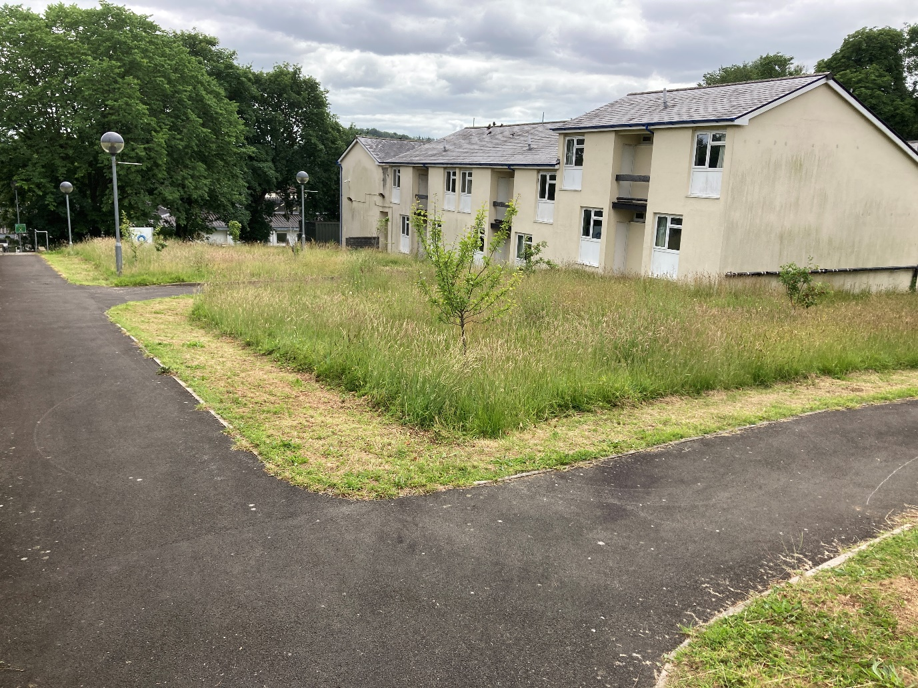
Purpose
The meadow expansion project aimed to create pollinator and ground mammal habitats, enhance biodiversity, and provide immersive educational landscapes for students, staff, and the public. These meadows contribute to ecological connectivity and resilience across both campuses.
NRAP Link
The meadow expansion project directly supports NRAP Objectives 2, 3, and 4 by safeguarding and enhancing habitats of principal importance, increasing ecological resilience, and tackling key pressures on species. By converting large areas of amenity grassland into diverse meadow habitats, the project provides essential resources for Section 7 species such as pollinators (including Marsh Fritillary and carder bees), ground-nesting birds like Skylark, and mammals such as hedgehogs. This shift from intensive mowing to a cut-and-collect regime reduces soil nutrient levels, encouraging plant diversity and creating structurally rich habitats that support a wide range of invertebrates and associated food webs. The meadows act as ecological corridors, improving connectivity across campus landscapes and buffering against climate-related stresses. Furthermore, the project addresses the pressure of habitat loss by restoring species-rich grasslands, reducing fragmentation, and promoting sustainable land management practices

Scale
- Lampeter: Expanded from 2,711 m² to 21,586 m²
- Carmarthen: Expanded from 6,243 m² to 22,663 m²
Design & Features
- Maintained edges and winding pathways
- Informative signage explaining biodiversity benefits
- Predominantly natural seedstocks, supplemented with National Botanic Garden of Wales meadow seed mix
Section 7 Species Benefiting
Pollinators: Marsh Fritillary, Brown-banded Carder Bee
Birds: Skylark, Linnet, Yellowhammer
Mammals: Hedgehog
Activities
- Annual or biannual mowing using cut-and-collect to reduce soil nutrients
- Spreading established meadow hay to diversify seedstock
- Training and site visits with National Botanic Garden of Wales and Royal Forester
Outcomes
- Increased bird and insect numbers compared to grass lawns
- Regular sightings of ground mammals and hedgehogs
- Enhanced ecological resilience and improved campus aesthetics
Future Plans
Photo-point monitoring and species surveys, explore further meadow expansion, species diversification and connectivity improvements.
Before and After Maps
The images below show the expansion of meadows across both campuses from 2022-2025.
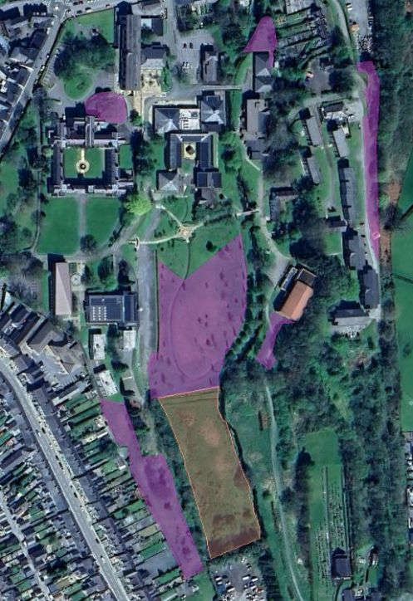
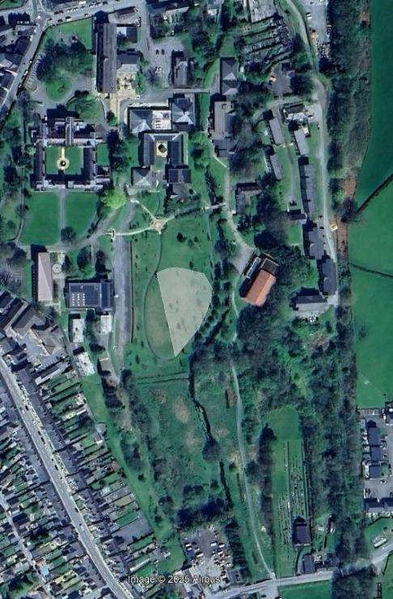
Figure 2 Carmarthen Meadows 2025
Figure 1 Lampeter Meadows 2022
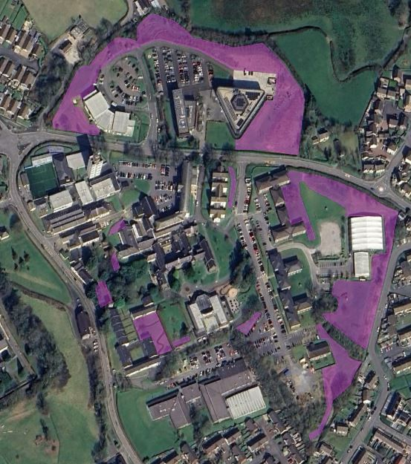
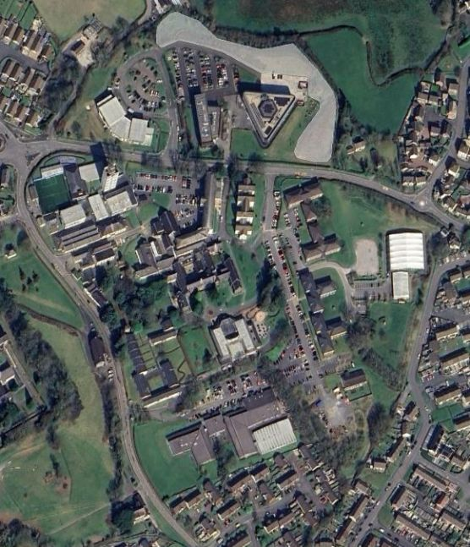
Figure 3 Carmarthen Meadows 2022
Figure 4 Carmarthen Meadows 2025

Case Study: Lampeter Himalayan Balsam Pulling Event
Date: 21 May 2024 (with follow-up pull in August 2024)
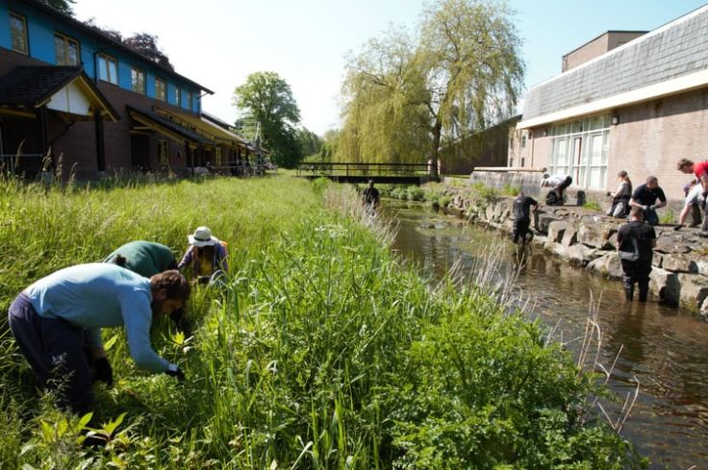
Volunteers removing Himalayan balsam along the Dulas River at Lampeter campus.
Purpose
The event was designed to provide a practical training landscape for volunteers within the wider community. Situated in the town centre of Lampeter, the campus offered an ideal location for training on Himalayan balsam management, covering fundamental principles, seasonality, and practical skills for riverbank habitats. A secondary benefit was the control of invasive weeds on campus.
NRAP Link
The Himalayan balsam pulling initiative at Lampeter campus exemplifies NRAP Objective 4 by actively tackling a key pressure on species and habitats: the spread of invasive non-native plants. Himalayan balsam is a fast-growing annual that outcompetes native vegetation, destabilizes riverbanks, and increases sedimentation risk, which can degrade water quality and aquatic habitats. Its dominance along the Dulas River posed a significant threat to the integrity of this SSSI & SAC designated watercourse, reducing habitat diversity and impeding natural flow. By removing balsam before seed set and conducting a follow-up pull to catch late growth, the project prevented further colonization and seed dispersal, safeguarding riparian habitats for Section 7 species such as otters, amphibians, and native invertebrates. This intervention not only restores ecological balance but also reduces long-term management pressures, demonstrating proactive compliance with Section 6 duties.

Partners
Ceredigion Council, West Wales Rivers Trust
Activities
- Riverside training workshop on balsam ecology and eradication methods before pulling began.
- Practical pulling along both banks of the Dulas River, covering approximately 1,200 m².
- A second pull was undertaken three months later to catch any late growth plants.
Outcomes
- Significant reduction in balsam propagation for the growing season.
- Maintained free-flowing river conditions into late summer.
- Enhanced volunteer knowledge and community engagement.
Educational Component
Talks on invasive species, biodiversity importance, and practical training for pulling and alternative eradication measures.

Case Study: Carmarthen Nature Pond Project
Date: August 2024
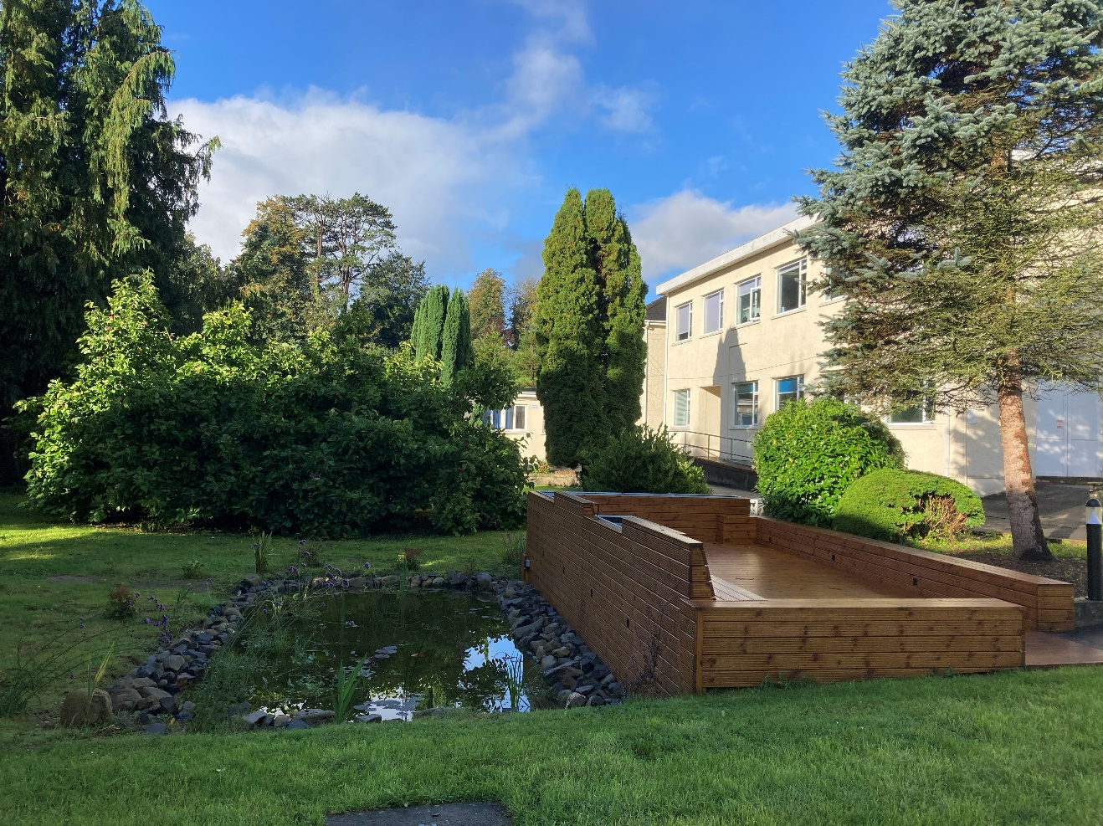 Carmarthen Nature Pond

Purpose
The project aimed to provide a natural water source for birds, ground mammals, and insects, while creating a blue habitat and marginal boundary habitat. It also serves as an educational landscape for students and the public, highlighting the importance and value of biodiversity amenity projects.
NRAP Link
The Carmarthen Nature Pond Project strongly aligns with NRAP Objective 1 by creating an educational and engagement-focused landscape that immerses students, staff, and the public in biodiversity principles. The pond serves as a living classroom, demonstrating the ecological value of blue habitats and marginal planting, and fostering community involvement through design input and interpretation features. Under NRAP Objective 3, the project enhances ecosystem resilience by restoring a degraded concrete pond into a dynamic wetland habitat, introducing structural diversity through shelves, native planting, and marginal refuges. These features support Section 7 species such as amphibians (Common Frog), pollinators, and dragonflies, while improving connectivity between green and blue spaces on campus. In meeting NRAP Objective 4, the project addresses key pressures by replacing an artificial, low-value feature with a natural system that mitigates runoff, improves water quality, and reduces habitat fragmentation. By prioritizing nature-based solutions, the pond not only delivers biodiversity gains but also contributes to climate adaptation and long-term sustainability.
Design & Features
- Shelves for varied depths
- Native planting
- Natural planted border
- Marginal plants and rock beds
Target Species (Section 7 Priority)
Birds (House Sparrow, Swift), Amphibians (Common Frog), Dragonflies,
Pollinators (Marsh Fritillary, Carder Bees)
Funding & Partnerships
Funded through Local Places for Nature (LPFN) with Carmarthenshire Council as funding provider.
Activities
- Excavation of old failed concrete pond
- Hardcore used to create new bank with native shade plants (bluebells, snowdrops, wild garlic)
- Removal of old stepped area and installation of accessible decking and seating
- DDA-compliant grass path and pagoda for public enjoyment
- Student involvement in design and planting selection
Outcomes
- Increased biodiversity: birds, dragonflies, foxes using pond as water source
- High insect activity during summer (informal observation)
- Space transformed into a popular wellbeing area for staff, students, and public

Educational and Engagement Benefits
Students engaged in design and planting; public access improved through inclusive infrastructure.
Future Plans
Monitoring planting density to avoid aeration needs; mulch build-up checks; investigating additional pond and ephemeral pond sites.



